## Y.Patil College of Engineering Akurdi.

*A*

*Project Report* On

Performing tests on Currency Converter

SUBMITTED BY

NAME: Vikas Mane(B1921152) NAME: Abhijeet Bhalekar(B1921155)

CLASS: BE-B

GUIDED BY

Prof. P.B.Deshmukh



## COMPUTER ENGINEERING DEPARTMENT

Academic Year:2021-22

D.Y.Patil College of Engineering,Akurdi.



**CERTIFICATE**

This is to certify that **Mr. Vikas Mane(B1921152),Abhijeet Bhalekar(B1921155)**, a students of B.E. (Computer Engineering Department)

## Batch 2021-2022, has satisfactorily completed a project report on “**Performing tests on Currency Converter**” under the guidance of **Prof. P.B.Deshmukh**.towards the partial fulfillment of the fourth year Computer Engineering Semester I of Pune University.

Prof. P.B.Deshmukh Dr. D.A.Potey Project Guide Head of Department

# CONTENTS

1. Problem Statement and Objectives
2. Introduction
3. Methodology
4. Result
5. References
6. **PROBLEM STATEMENT**

Perform Desktop Application testing using Automation Tool like JUnit generate Test Report by Using tool like Apache Maven.

# INTRODUCTION

* White Box Testing is a software testing method in which the internal structure/ design/ implementation of the item being tested is known to the tester.
* Unit Testing of software applications is done during the development (coding) of an application. The objective of Unit Testing is to isolate a section of code and verify its correctness. In procedural programming a unit may be an individual function or procedure The goal of Unit Testing is to isolate each part of the program and show that the individual parts are correct. Unit Testing is usually performed by the developer.
* Black Box Testing is a software testing method in which the internal structure/ design/ implementation of the item being tested is not known to the tester

# METHODOLOGY

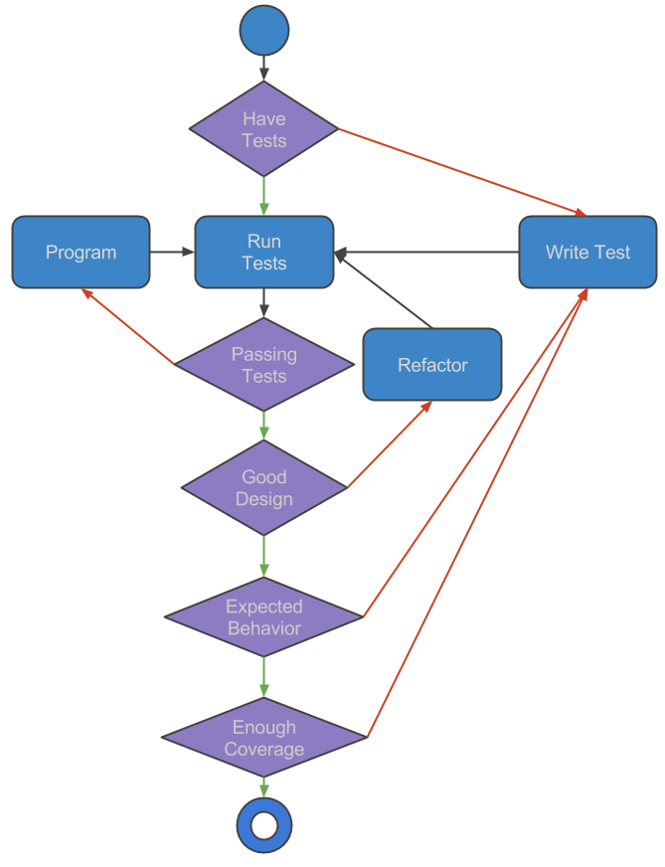

1. **OUTPUT**

1.TEST

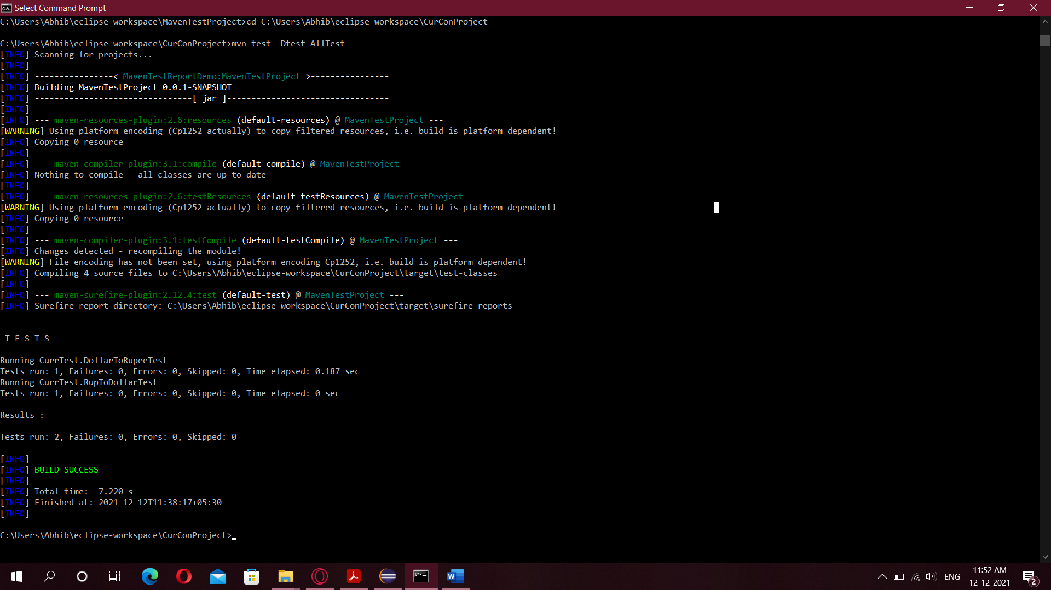

2.ALL TESTS

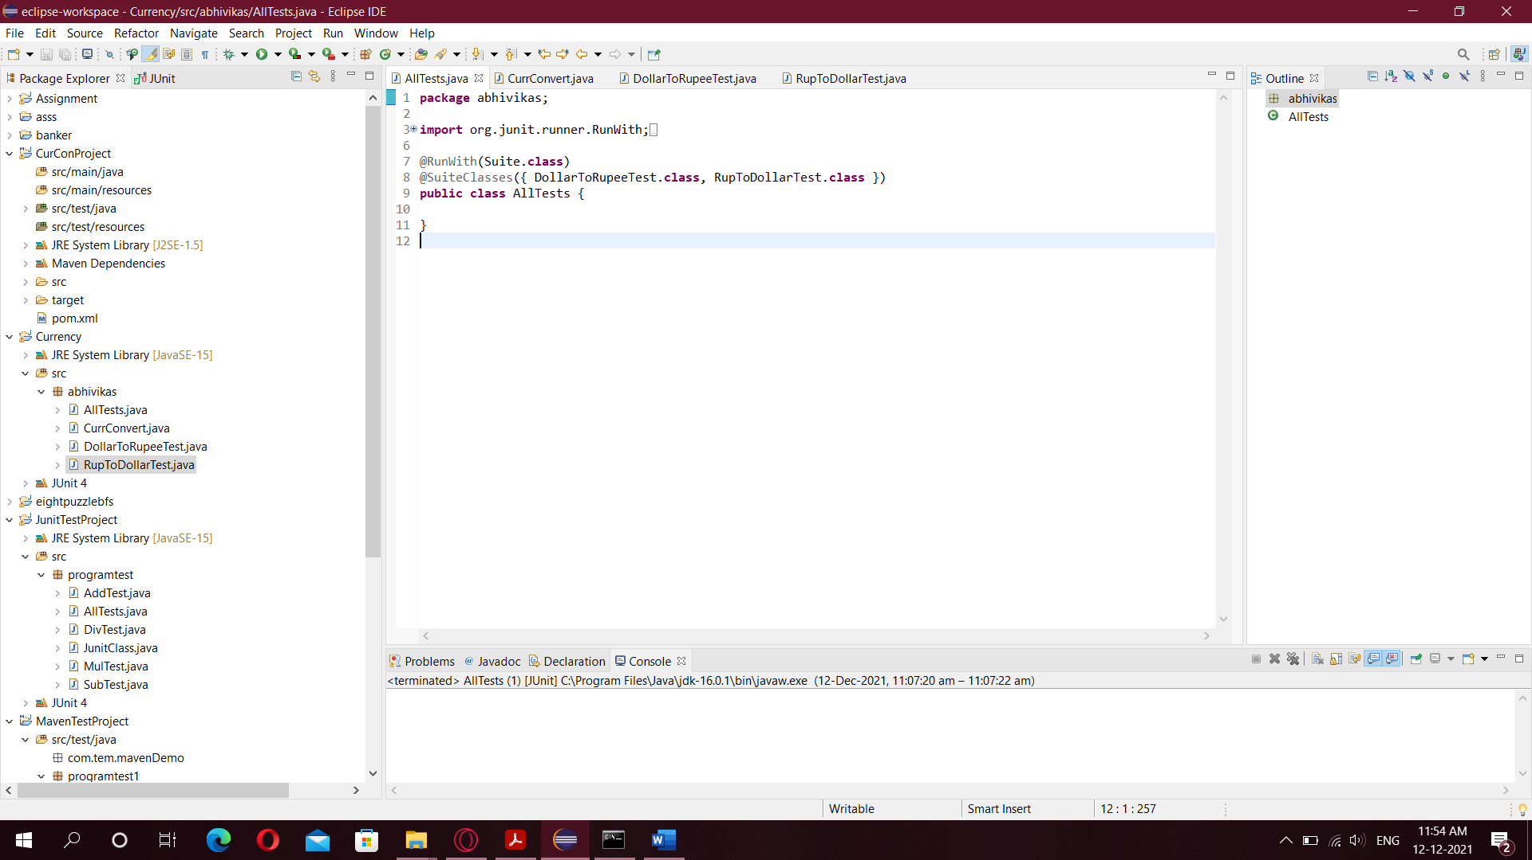

3.Main Code

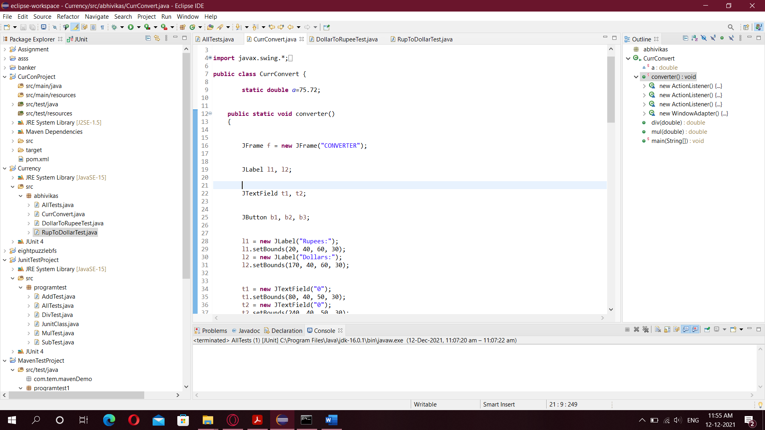

4.Dollar to rupee

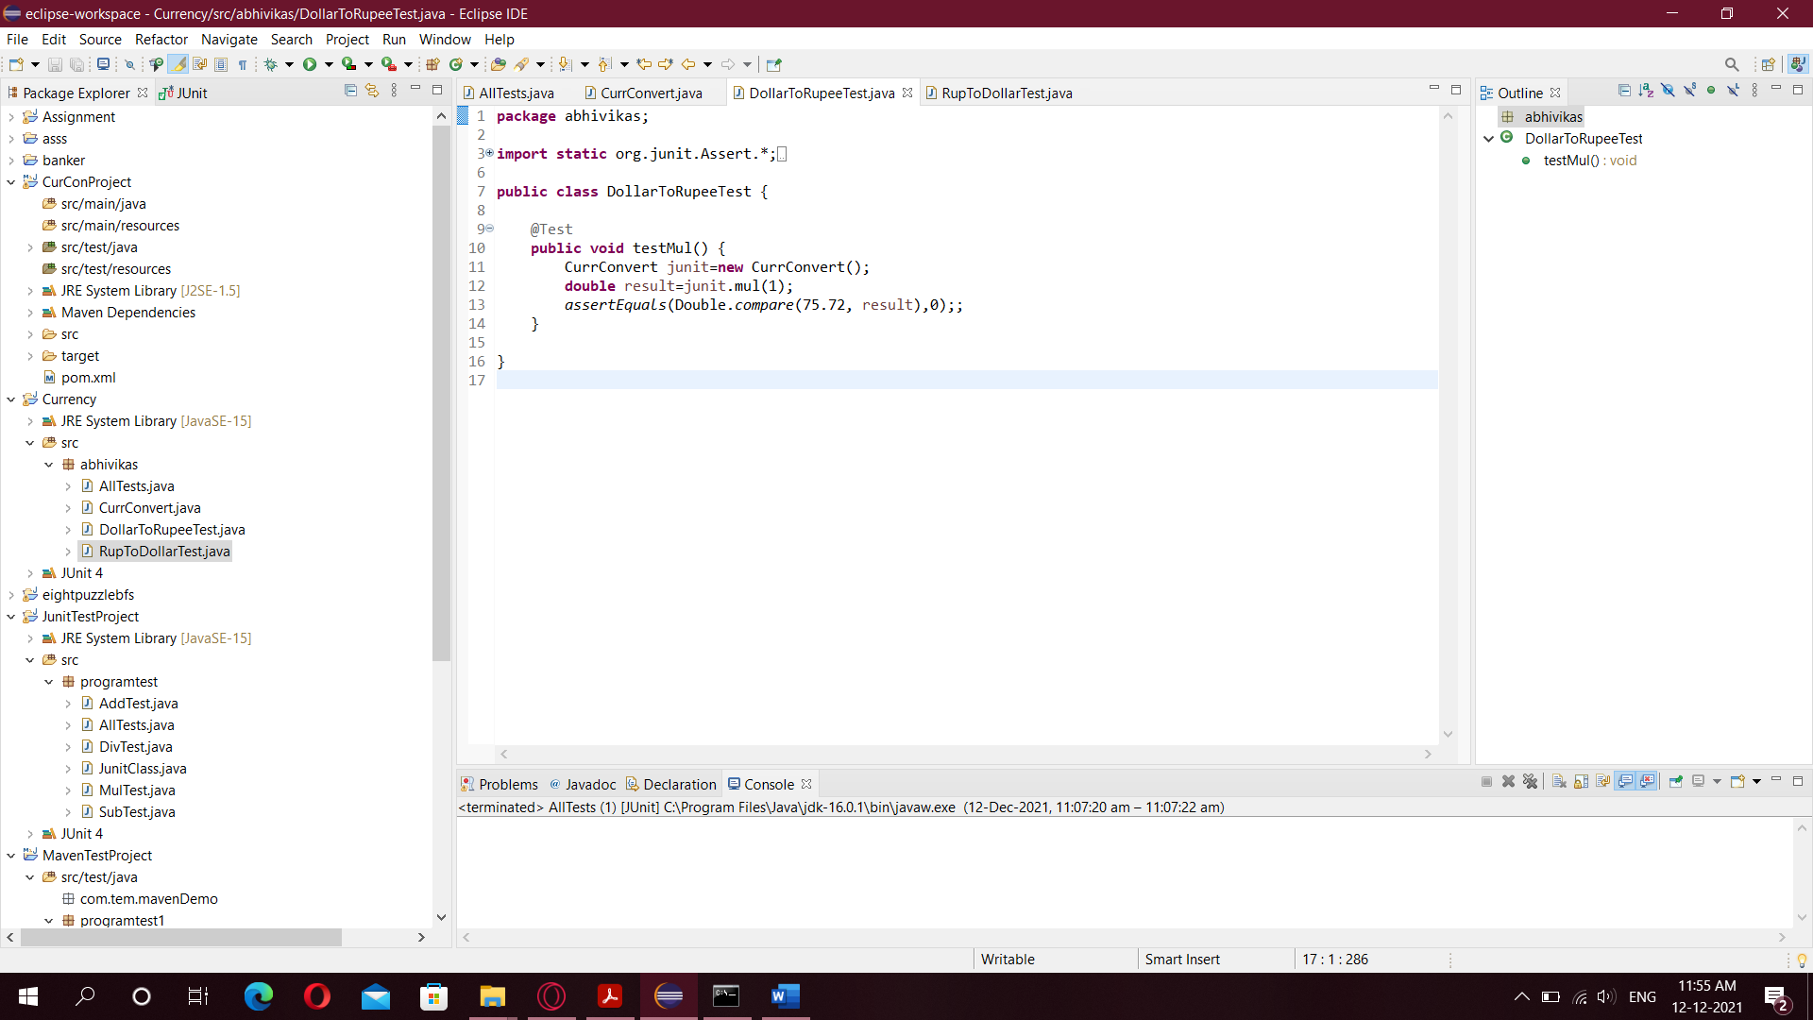

5.Rupee to Dollar

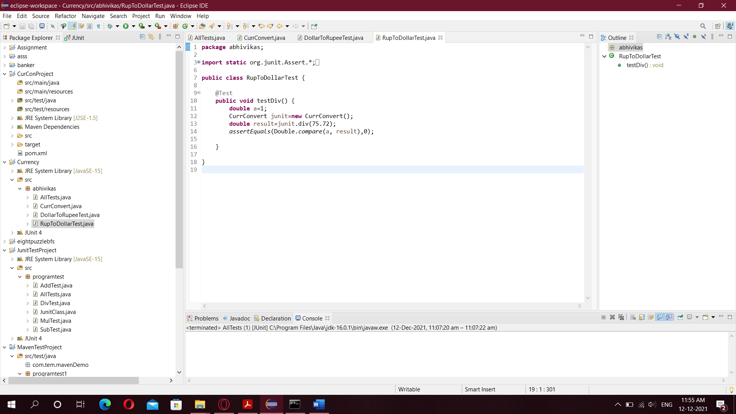

# 6.REFERENCES

1. https://maven.apache.org
2. https://mvnrepository.com/artifact/junit/junit
3. https://mvnrepository.com/artifact/org.seleniumhq.selenium/selenium-server
4. https://docs.oracle.com/en/database/oracle/machine-learning/oml4r/1.5.1/oread/creating-and-modifying-environment-variables-on-windows.html